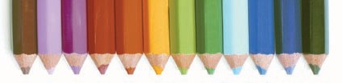
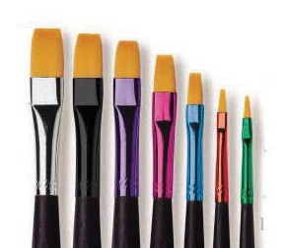
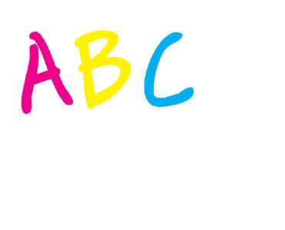
Scoil an Fhraoich Mhoir

Booklet for Parents
of
Infants Starting School

abcdefg hijklmnop qrstuvwxyz
?!@&%

0123456789

Foreword

Fáilte romhat agus roimh do pháiste.

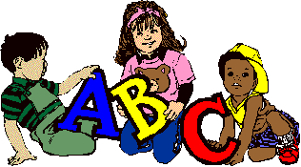

Starting school is one of the first big changes in the life of your child. Most children now attend play school but for some it will be their first time facing the wider world of classroom and school. This may seem a big step for someone so small but most children manage it without any great fuss or stress - and in fact take to it like ducks to water.

However, it is also a time when parents and teachers should take special care to ensure that the transition from home to school is as smooth as possible. If the child’s first experience of school is one of happy involvement, a very good foundation will have been laid for fruitful school years ahead.

It is important too, particularly during the first year that parents understand what the aims of the school are, as many may be expecting too much in the way of academic achievement.

We know from experience that parents are very anxious to help in any way possible. We have, therefore, included some ideas for the home, which should stimulate the child’s interest and nurture their desire to know more.

With these aims in mind we have put together this little booklet as a general guide for parents. It deals briefly with the period before your child comes to school and their introductory stage in Junior Infants.

We trust you will find it helpful and that your child will be happy and fulfilled with us.

Getting Ready for Learning

Children are natural learners. They have an inbuilt curiosity and an eagerness to know more about everything – about themselves, about others and about the world around them. And they learn fast – but only when they are ready and their interest is aroused.

Because they come to us so young we must guard against putting pressure on them to learn what they are not yet ready for. Demanding too much too soon can switch a child off completely. At the same time, we must cultivate readiness so that they can get moving as soon as possible.

The rates of progress of children can vary greatly.

We try to give them an opportunity to move ahead at their own pace or as near to it as possible.

Our first year in school therefore, is mainly about settling in, relating to others, making friends, feeling happy and gradually getting used to the routine of the school. On the learning side the emphasis is on getting children ready for learning by –

Developing their oral language and expression.
Sharpening their senses, especially seeing, hearing and touching.
Developing physical co-ordination especially of hand and fingers.
Extending their concentration span and getting them to listen attentively.
Learning through play – the most enjoyable and effective way.
Co-operating with the teacher and other children. Performing tasks by themselves.
Emotional development - increasing self-esteem and confidence.
Working with others and sharing with them - social development.
Getting each child to accept the general order, which is necessary for the class to work well.

Before Your Child Starts…

You should ensure that your child is as independent as possible- physically, emotionally and socially. If they can look after themselves in these areas, they will feel secure and confident and settle in readily.

It would help greatly if your child is able to-

Button and unbutton their coat and hang it up.
Can take on and off their shoes - Velcro closing shoes are of great help.
Use the toilet without help and manage pants/pinafore buttons
Also encourage personal hygiene and cleanliness. Your child should know to flush the toilet and wash their hands, without having to be told.
Use their hanky when necessary.
Share toys and playthings with others and “take turns”.
Tidy up and put away their playthings.
Remain contentedly for a few hours in the home of a relation, friend or neighbour. If they have this experience, then separation from parents when they start school will not cause them any great anxiety.

Preparing for the ‘Big Day’

The child’s first day at school is a day to remember for the rest of their life. You can help to make it a really happy one for them.

Tell them about school beforehand, casually, and talk about it as a happy place where there will be a big welcome for them and they will meet new friends.
Don’t use school or the teacher as a threat. “If you behave like that for teacher she’ll murder you” though said light-heartedly can make some children very apprehensive.
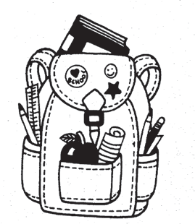
Your child will like to have their new uniform (jumper/tie available in Shaws, grey trousers/skirt widely available, tracksuit available in Colgans Sports) and their new bag when they begin. These help them identify more readily with the school and other children.

If you have joined the school book rental and resources scheme, everything your child needs will be ready for them when they come to school. If you decide to purchase your own the books will be taken by the teacher on the first day of school and the teacher will hold on to them until such time as they are needed. This minimises books getting lost. Please have your child warned of this fact; in case they think they will never see the books again. Your child will only feel important if they have something in their school bag, so perhaps you could buy a copy or colouring book for them, which they could use at home. Limit the number of pencils, crayons and markers in their bag - two pencils are enough colours etc. will be available in school and they will only lose their own.
Discourage them from bringing toys and other play things to school.

The Big Day

Coming in…
When you arrive at the classroom, be as casual as you can, So, having assured them you will be back to collect them, give them a hug, wish them goodbye and make your getaway without delay. Remember it is best to drop and go. The teacher will greet your child and bring them to their chair. Most children are so absorbed in their new surroundings they will hardly notice you are gone but if a child does become upset we will distract them. It is rare for a child to remain upset for long once the parent is gone.

Packed Lunches
Lunch is an important meal for school going children.
It should provide one third of their recommended daily allowance of nutrients without being high in fat, sugar or salt. It should also provide dietary fibre (roughage).
The traditional packed lunch of milk and sandwiches is under attack from a range of convenience foods like crisps, sweets, biscuits, chocolate and soft drinks.
Parents and teachers are concerned about this trend but some find it difficult to come up with popular healthy alternatives. We will ask you to encourage a healthy lunch right from the start in line with the school’s Healthy Lunches Policy. Also, please, only give your child something you feel he/she can easily manage
to eat. Remember after the first fortnight they will be in school for two breaks. First break is at 11.00.
Children do not bring food onto the yard but are given time before or after break to have a snack and a drink. Big break is at 1.00. Again children are given time before or after break to eat the bigger part of their lunch. Try and get your child into the habit of eating something at both breaks. Encourage them to use their lunch time for eating as they may otherwise find they do not have enough time. The school also works with a private company called The Lunch Bag who deliver ordered lunches on a daily basis. Many parents use this facility on a daily basis while others use it occasionally. Further information is available from the school office.

The following guide is designed to help you provide quick, appetising, and nutritious lunches for your children.

Bread & Alternatives
Bread or rolls, preferably wholemeal. Rice – wholegrain.
Pasta – wholegrain. Potato Salad.
Wholemeal Scones.

Savouries
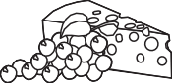
Lean Meat. Chicken/Turkey.
Tinned Fish e.g. tuna/sardines. Cheese, including Edam, blarney, cottage, Quiche, Pizza.

Fruit & Vegetables
Apples, Banana,
Peach, Plum, Pineapple cubes, Mandarins, Orange
segments, Grapes, Fruit Salad, Dried fruit, Tomato, Cucumber, Sweetcorn, Coleslaw, Celery.

Drinks
Water is the best Milk
Natural Fruit juices.
High juice Squashes, i.e. low sugar content.
Homemade soup. Yoghurt.

Start with the Basics
A healthy packed lunch should contain bread or an alternative, a savoury filling which provides protein, a suitable drink and some fruit and/or vegetables.

A Word about Milk
Growing children should get approximately one pint of milk a day, or its equivalent as cheese, yoghurt or milk pudding. This ensures that they get enough calcium, which is essential for healthy bones and teeth. If a child does not drink a glass of milk at lunch, encourage him or her to have a carton of yoghurt or a small helping of cheese instead.

Lunch Boxes
The school encourages the children to recycle and be aware of the environment. Buy a plastic reusable lunch box and a similar drinks container that the children can use over and over again.

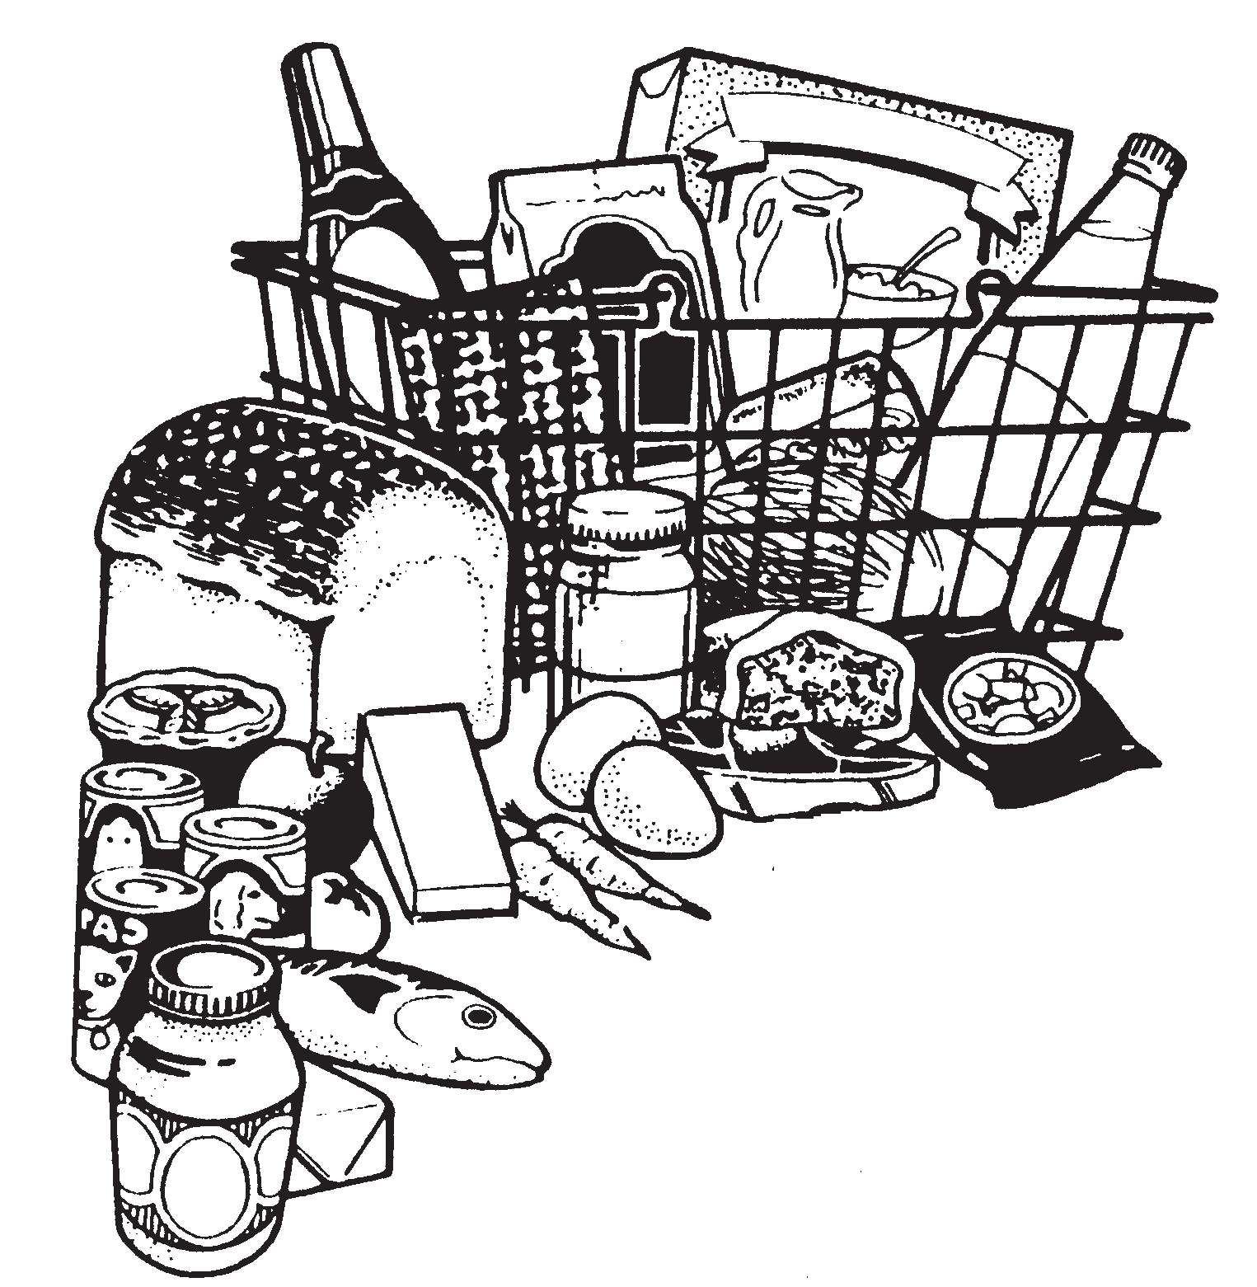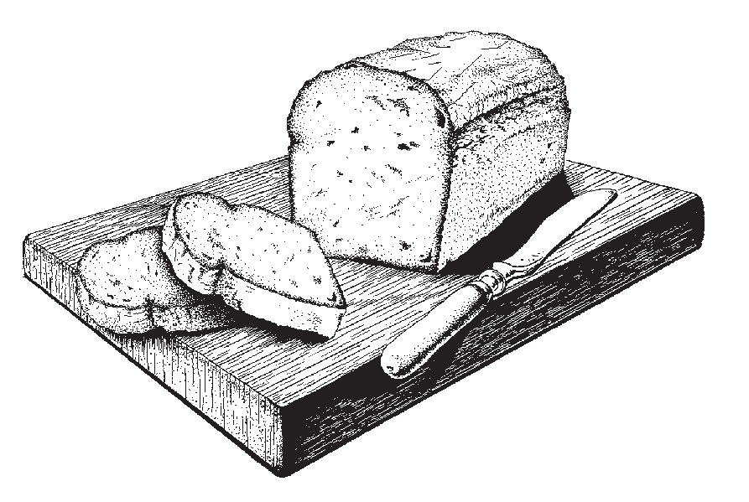

Going Home
Be sure to collect him/her on time (12pm for the first two weeks and 1.30pm thereafter) Children can become very upset if they feel they are forgotten.
Wait until the teacher is ready and hands over your child to you.
If at any time the collecting routine has to be changed ensure you tell the child and the teacher.
If you are delayed, phone the school and let us know. We will explain to your child why they have not been picked up and their teacher will arrange for their supervision.

Handling the Upset Child

In spite of the best efforts of both teacher and parents a small number of children will still become upset. If your child happens to be one of them don’t panic. Patience and perseverance can work wonders.

A Word of Advice
Trust the teacher. She is experienced and resourceful and is used to coping with all kinds of starting –off problems.

Try not to show any outward signs of your own distress. Sometimes the parents are more upset than the child and are the main cause of his anxiety.
When you have reassured them, leave as fast as possible. The teacher can distract them more easily when you are not around.
Should we be unable to calm your child we will phone you.
You must be firm from the start. Even if a child is upset you must insist that they stay for a short
time-even ten minutes. They must never feel that they are winning the psychological battle of wills.

As Time Goes on…
School opens at 8.50a.m. and teaching commences at 9.10am. To ease the child into the school routine we have a policy where Junior Infants go home for the first two weeks at 12.00p.m. (so no big lunch).
After that they go home at 1.30p.m. Please make sure that your child is collected at 1.30p.m. as the teacher needs that hour between 1.30p.m. and 2.30p.m. to clean up after the day, plan their work, meet with parents, meet other support staff and carry out other work assigned to them by the principal such as the release of other class teachers.
Get your child into the habit of being in good time for school from the beginning. Although teaching is not scheduled to start until 9.10am the teacher will correct homework, issue notices and settle the class down in preparation for teaching.

Children need plenty of rest after the effort and excitement of a day at school. You should ensure that your child gets to bed early and has a good night’s sleep.
When your child has settled in and hopefully, looks upon school as a “home from home” do continue to show interest in their daily adventures. Give them an ear if they want to tell you things-but don’t pester them with questions.
Mind that you take some of your child’s “stories” with a pinch of salt.
If your child’s progress is slow do not compare them adversely with other children while they are listening. Loss of self- esteem can be very damaging to them.
Be careful too about criticising their teacher in their presence. Remember that she is their mother figure while they are at school and for their own well-being it is important that your child has a good positive image of her.
This last caution applies to your child’s image of the school as well. Your child’s school is always “the greatest”- whatever its faults.
Your child is not going to be a model of perfection all the time- thankfully. You should try to have patience with their shortcomings and praise for their achievements.
Children often “forget” or relay messages incorrectly, so please, check with the school if in doubt.
Each year parents receive reports, booklists, book rental and resource scheme details through the school app in the last term. Please ensure that you have downloaded the app.
Some Important Areas of Early Learning

Developing their Command of Spoken Language.

It is important that the child’s ability to talk is as advanced as possible. It is through speech that your child communicates their thoughts and feelings, their needs and desires, curiosity and wonder. If they cannot express these in words they will tend to remain silent and will often withdraw from the learning activity of the class. This can be the first sign of failure in the school system and must be remedied, if at all possible. That is why a lot of attention is given to language development in the first years of school.

You Can Help…
Talk to your child naturally and casually about things of interest that you or they may be doing-at home, in the shop, in the car, etc. Remember that all the time they are absorbing the language they hear about them. It takes them a while to make it their own and to use it for their own needs.
Try to make time to listen when your child wants to tell you something that is important to them. But don’t always make them the centre of attention.
Answer genuine questions with patience and in an adequate way. Always nurture your child’s sense of curiosity and wonder.

Introduce your child gently to the ideas of why? How? When? Where? If? etc. These demand more advanced language structures.
They will have their own particular favourite stories that they never tire of hearing. Repeat them over and over again and gradually get your child to tell them to you.

First Steps in Reading
Ability to read is the foundation for all future progress in our school system. However, learning to read is a gradual process and a lot of preparatory work must be done before a child is introduced to his first reader.

We very deliberately do not rush or push children into reading. We get them ready for it over an extended period. Reading is something to be enjoyed. It should never start as a chore for the small child.

You can Help..
Have attractive colourful books in the home.
Read your child a variety of stories from time to time. They will get to associate these wonderful tales with books and reading.
You must convey to them gradually that books are precious things. They must be minded and handled carefully and put away safely.
Look at the pictures with your child and talk to them about what they say.
Read your child nursery rhymes. They will learn them off their own bat. Don’t try to push them.

Above all, don’t push them with their early reading. You may turn them against it for evermore.
Remember that the teacher is the best judge of what rate of progress is best suited to each child.
Sing the alphabet song with your child, so that they at least heard of the letters. If they know what each one looks like, all the better.

Understanding Maths

First a Word of Warning
Maths for the small child has nothing to do with “sums” or figures or tables or adding and subtracting. These will all come much later. Maths is really part of the language they use in understanding and talking about certain things in their daily experience e.g.
Children associate certain numbers with particular things
– two hands, four wheels, five fingers etc. Counting – one, two, three, four, etc.
Colours – black, white, red, green, etc.
Prepositions (telling position) and their opposites: over/under, before/after, inside/outside etc.
Matching/Sorting – objects of the same size/colour/ texture/shape etc.
Odd One Out – difference in size/colour etc.
Understanding of these concepts comes very quickly for some children. For others it takes a long time. Be patient. You cannot force Maths understanding on a child.

But You Can Help…
In the course of your ordinary daily routine in the home, in the shop, in the neighbourhood you should use suitable opportunities to casually introduce the maths vocabulary referred to above. E.g. How many cakes? The glass is full/empty. We turn left at the lights.
The child gets to understand Maths best by handling and investigating and using real objects. This has been their natural method of learning since they were a baby. This at times can be a nuisance but if it allows them to do the learning themselves the final result is well worth it.

Gaeilge
All children enjoy learning another language besides their own language. They have no difficulty in picking it up because it fascinates them as another code of communication.

They are free of any hang-ups about Irish unless they become aware that the home attitude towards it is not good. So please be careful that anything you say does not give a negative attitude to your child.

We would want all parents to give every encouragement and help to the small ones in their efforts to acquire Irish. If they learn new words in school encourage them to use them at home. Use little Irish phrases or words now and again. Children are delighted to find out that their parents are into their new code as well. If they must learn Irish, let them enjoy it and master it to the best of their ability.

Getting Ready For Writing
Making letters on paper is not easy for the small child. They must learn to hold the pencil properly and make regular shapes. Their hand and finger muscles are only gradually developing at this stage.

You Can Help…
They must develop the ability to get the hand and eye working together. This is very important. Get your child manipulating toys like:
- Jigsaws, Lego, beads to thread etc
- Pleistocene (Marla) to make their own shapes
- A colouring book and thick crayons
- Sheets of paper that they can cut up with a safe scissors

When your child begins to use a pencil make sure that they hold it correctly at the start. It will be difficult to change them later.
Your child may be making block letters at home even before they come to school. This is fine. But when they start making lower case letters at school you should try to get them to discontinue the blocks and practise their new system whenever they feel like it. Consult the teacher about this.
Don’t discourage left-handedness. If that is your child’s definite natural inclination, don’t attempt to change them.

Other Areas of the Curriculum
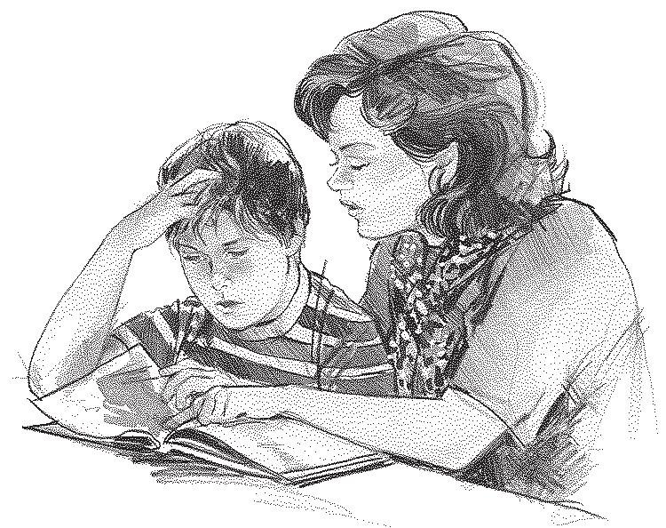
The child in juniors learns a lot through many other activities, which do not need any elaboration here. Their general development is enhanced through Art & Craft, P.E., Music, Nature and of course through Religious Education.
In regard to the last area its moral and social aspects are covered right through the school day e.g. kindness to others, sharing with them, saying we are sorry, being aware of God through the beauty of nature etc.
The children learn their prayers and bible stories gradually. Again, as in the other areas we referred to already, the child will benefit from practising at home what they have learned at school. They can then make their own contribution to the usual family prayers.
Social skills are very important. We encourage good manners at all times, please/thank you, addressing teachers properly, being courteous to fellow students and teachers. It is important to ask your child whom they played with at school and to ensure they aren’t alone, also encourage mixing rather than being dependent on one friend only. Rough behaviour is totally discouraged in the playground. You will find a list of school rules and policies on the school website.

Parting Thoughts

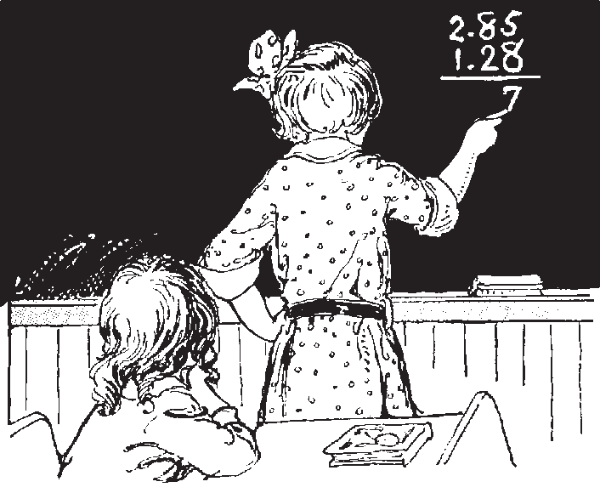
Who is the Boss? Bit by bit the child will get used to the
general discipline of the
classroom. They will get to understand very quickly that in certain important matters an instruction from the teacher must be obeyed promptly and without question.

Teacher and Parent
At the early stages some parents meet the teacher almost daily and this is a very desirable thing. However, if there is something in particular that you would like to discuss you can arrange to meet her at a time when you both can have a little peace and quiet.

Easy Does It
There are lots of ideas and suggestions in this little book as to how you can help your child. We are not advocating that you do ALL of these with your child in a systematic way. But if you find from time to time that they enjoy a fun approach to certain aspects of learning then we would say – give it a go – but remember don’t overdo it.

Our Hope
We are offering this Guide to Parents as a little practical help in dealing with the education of their children at the very early stages. We will be very happy if you dip into it from time to time and find something in it of value to you and your child.

Together We Learn

